Day 10 Audio In Android

Activity_main.xml

<?xml version="1.0" encoding="utf-8"?>  
<LinearLayout xmlns:android="http://schemas.android.com/apk/res/android"  
 xmlns:app="http://schemas.android.com/apk/res-auto"  
 xmlns:tools="http://schemas.android.com/tools"  
 android:layout_width="match_parent"  
 android:layout_height="match_parent"  
 android:orientation="vertical"  
 tools:context=".MainActivity"  
 android:background="@drawable/pexel">  
  
 <TextView  
 android:layout_width="match_parent"  
 android:layout_height="wrap_content"  
 android:text="Play Music"  
 android:id="@+id/txmusic"  
 android:textSize="40dp"  
 android:layout_marginTop="150dp"  
 android:gravity="center"  
 android:textColor="@color/design_default_color_surface"/>  
  
 <Button  
 android:id="@+id/btplay"  
 android:layout_width="250dp"  
 android:layout_height="wrap_content"  
 android:layout_marginTop="50dp"  
 android:text="START MUSIC"  
 android:gravity="center"  
 android:layout_marginLeft="80dp"  
 android:textColor="@color/design_default_color_surface" />  
  
 <Button  
 android:id="@+id/btpause"  
 android:layout_width="250dp"  
 android:layout_height="wrap_content"  
 android:layout_marginTop="10dp"  
 android:layout_marginLeft="80dp"  
 android:text="PAUSE MUSIC"  
 android:gravity="center"  
 android:textColor="@color/design_default_color_surface"/>  
  
 <Button  
 android:id="@+id/btstop"  
 android:layout_width="250dp"  
 android:layout_height="wrap_content"  
 android:layout_marginLeft="80dp"  
 android:layout_marginTop="10dp"  
 android:text="STOP MUSIC"  
 android:textColor="@color/design_default_color_surface"/>  
</LinearLayout>

MainActivity.java

package com.example.music;  
  
import androidx.appcompat.app.AppCompatActivity;  
import android.media.MediaPlayer;  
import android.os.Bundle;  
import android.view.View;  
import android.widget.Button;  
  
public class MainActivity extends AppCompatActivity implements View.OnClickListener {  
  
 Button btplay,btpause,btstop;  
 MediaPlayer mediaPlayer;  
  
 @Override  
 protected void onCreate(Bundle savedInstanceState) {  
 super.onCreate(savedInstanceState);  
 setContentView(R.layout.*activity_main*);  
  
 btplay = (Button) findViewById(R.id.*btplay*);  
 btpause = (Button) findViewById(R.id.*btpause*);  
 btstop = (Button) findViewById(R.id.*btstop*);  
  
 mediaPlayer = MediaPlayer.*create*(MainActivity.this, R.raw.*let*);  
  
 btplay.setOnClickListener(this);  
 btpause.setOnClickListener(this);  
 btstop.setOnClickListener(this);  
  
 }  
  
 @Override  
 public void onClick(View v) {  
 switch (v.getId ())  
 {  
 case R.id.*btplay*:  
 mediaPlayer.start ();  
 break;  
  
 case R.id.*btpause*:  
 mediaPlayer.pause ();  
 break;  
  
 case R.id.*btstop*:  
 mediaPlayer.stop ();  
 break;  
 }  
  
 }  
}

Output:

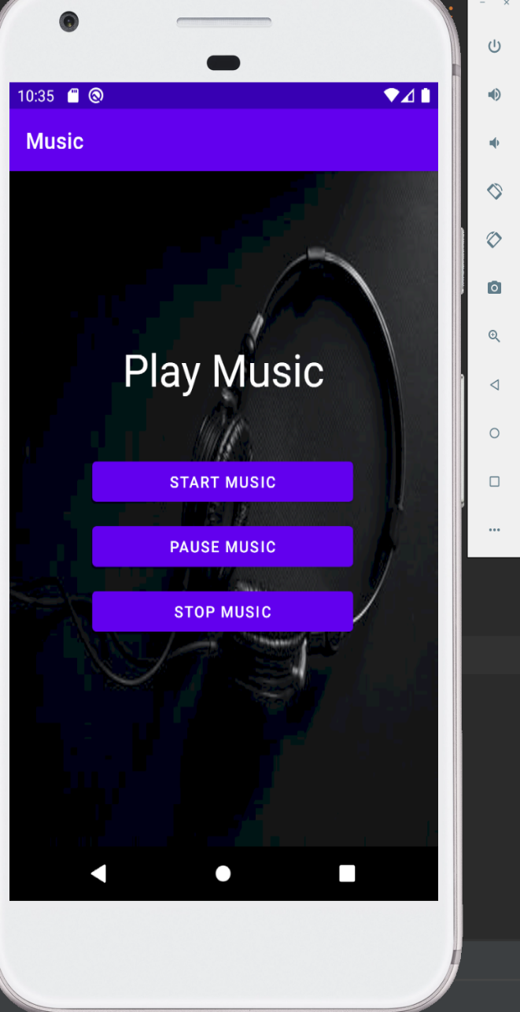 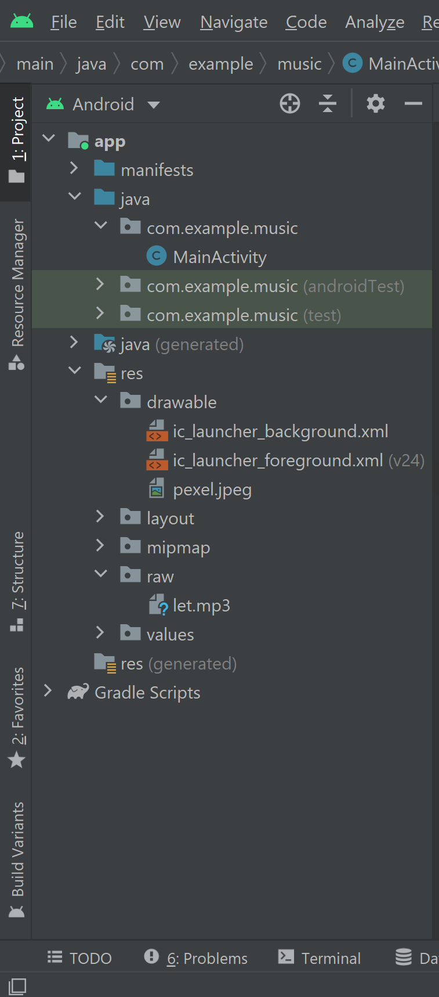

Video In Android:

Activity_main.xml

<?xml version="1.0" encoding="utf-8"?>  
<LinearLayout xmlns:android="http://schemas.android.com/apk/res/android"  
 xmlns:app="http://schemas.android.com/apk/res-auto"  
 xmlns:tools="http://schemas.android.com/tools"  
 android:layout_width="match_parent"  
 android:layout_height="match_parent"  
 tools:context=".MainActivity"  
 android:orientation="vertical">  
  
 <TextView  
 android:layout_width="match_parent"  
 android:layout_height="wrap_content"  
 android:textSize="40sp"  
 android:layout_marginTop="30dp"  
 android:gravity="center"  
 android:text="Video!!!"  
 android:textColor="@color/design_default_color_secondary"/>  
  
 <VideoView  
 android:layout_width="match_parent"  
 android:layout_height="wrap_content"  
 android:id="@+id/video1"  
 android:layout_marginTop="30dp"/>  
</LinearLayout>

MainActivity.java

package com.example.video;  
  
import androidx.appcompat.app.AppCompatActivity;  
import android.media.MediaPlayer;  
import android.net.Uri;  
import android.os.Bundle;  
import android.widget.MediaController;  
import android.widget.Toast;  
import android.widget.VideoView;  
  
public class MainActivity extends AppCompatActivity {  
  
 VideoView video1;  
  
 @Override  
 protected void onCreate(Bundle savedInstanceState) {  
 super.onCreate (savedInstanceState);  
 setContentView (R.layout.*activity_main*);  
  
 video1 = (VideoView) findViewById (R.id.*video1*);  
  
 MediaController mediaController = new MediaController (this);  
 mediaController.setAnchorView (video1);  
  
 //To set the path to the video  
 Uri uri = Uri.*parse* ("android.resouce://" + getPackageName () + "/" + R.raw.*letme*);  
 video1.setMediaController (mediaController);  
 video1.setVideoURI (uri);  
 video1.requestFocus ();  
 video1.start ();  
  
 video1.setOnCompletionListener (new MediaPlayer.OnCompletionListener () {  
 @Override  
 public void onCompletion(MediaPlayer mp) {  
 Toast.*makeText* (MainActivity.this, "Thank You....", Toast.*LENGTH_LONG*).show ();  
 }  
 });  
  
 video1.setOnErrorListener (new MediaPlayer.OnErrorListener () {  
 @Override  
 public boolean onError(MediaPlayer mp, int what, int extra) {  
 Toast.*makeText* (MainActivity.this, "Error....", Toast.*LENGTH_LONG*).show ();  
 return false;  
 }  
 });  
 }  
}

Output:

